Name: ___________________________________________ Date: ___________________
Culture, Early Man and Civilization Review Questions Mrs. Valdes/Mr. Craine

Directions: select the best possible answer that completes the following statements or questions.

Base your answer to question #1 on the map below and on your knowledge of Social Studies.

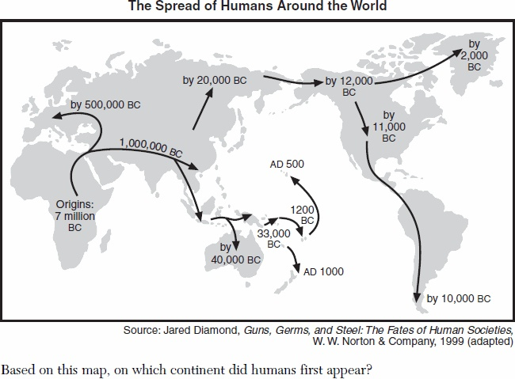
- Based on this map, on which continent did humans first appear?
- Asia
- Africa
- North America
- Australia

- Where does the archaeological evidence gathered by Louis and Mary Leakey suggest the earliest humans developed?
- Great Rift Valley
- Amazon rain forest
- Himalaya Mountains
- Philippine archipelago

- Some archaeologists believe the earliest human presence in the Americas is associated with the:
      - migration of nomads across the Bering Strait
      - exploration of the Caribbean by Europeans
      - movement of tribes during the Bantu migration
      - journey of traders along the Silk Roads

- Which characteristic was common of the ancient people of the Paleolithic Era?

- nomadic lifestyle
- influence of European cultures
- monotheistic religion
- written forms of communication
- Which of the following was a characteristic of the Old Stone Age?
      - farming
      - simple stone tools
      - written language
      - organized government

- Which heading best completes the partial outline below?

I ______________________________
A. Centralized governments
B. Organized religions
C. Different social classes
D. Specialization of labor (different people perform different jobs)

  - Economic development in Ancient Egypt
  - Cultural diffusion in Mohenjo- Daro
  - Features of the Old Stone Age
  - Characteristics of a Civilization

- The growth of maritime (sea) and overland trading routes led to:
- decreased interest in technology
- limited migration of people
- increased cultural diffusion
- the development of subsistence farming

- Archeologists refer to the period of time before people invented writing systems as:
- geography
- prehistory
- technology
- archeology

- Which characteristic was common of the ancient people of the Paleolithic Era?

      - nomadic lifestyle
      - influence of European cultures
      - monotheistic religion
      - written forms of communication

- Early peoples who moved frequently as they searched for the food they needed for survival are called:

a. hunters and gatherers
b. village dwellers
c. subsistence farmers
d. guild members

- How did the introduction of agriculture (farming) affect early peoples?

a. Societies became nomadic.
b. Food production declined.
c. Civilizations developed.
d. Birthrates decreased rapidly.

- What is the main reason the Neolithic Revolution is considered a turning point in world history?

a. Fire was used as a source of energy for the first time.
b. Spoken language was used to improve communication.
c. Domestication (taming) of animals and cultivation (growing) of crops led to settled communities.
d. Stone tools and weapons were first developed

- What was an important result of the Neolithic Revolution?

a. Food supplies became more reliable.
b. New sources of energy became available.
c. People became more nomadic.
d. Populations declined.

- During which period did the domestication of animals and growing of crops first occur?

a. Iron Age
b. Old Stone Age
c. Neolithic Revolution
d. Scientific Revolution

- • Planting wheat and barley
• Domesticating animals
• Establishing permanent homes and villages

At the beginning of the Neolithic Revolution, the most direct impact of these developments was on:

a. religion and government
b. transportation and trade
c. diet and shelter
d. climate and topography

- Which was true of food gathering societies in pre-historic times?

- society was highly industrialized
- the concept of private property was important
- there was a system of mass production
- the population tended to be small

- How did the introduction of agriculture affect the early peoples?

- societies became nomadic
- food production declined
- civilizations developed
- birthrates decreased rapidly

______________________________________________________________________________
Base you answer to question #18 on the diagram below and on your knowledge of social studies.

Nomads
Hunters and Gatherers
Simple Tools and Weapons

Farmers
Domestication of Animals
Establishment of Villages

- What is the best title for this diagram?

- elements of the belief systems
- characteristics of classical civilizations
- benefits of geography
- changes during the Neolithic Revolution

- One result of the Neolithic Revolution was:

- an increase in the number of nomadic tribes
- the establishment of permanent villages
- a greater reliance on hunting and gathering for food
- a decrease in trade between different cultural groups

- Scientists believe that early man believed in an afterlife because they have discovered that early man:

- carefully buried their dead with tools and weapons
- left their bodies out for wild animals to eat
- developed monotheism
- was nomadic

- Before towns and cities can develop in a society, the society first must establish a….

a. writing system
b. educational system
c. agricultural surplus
d. democratic government

- . A characteristic of polytheism is the belief in…

a. one god
- many gods
- reincarnation
- the Old Testament

23. The development of early civilizations usually depended on:

a. the formation of democratic governments
b. a location near large deposits of gold and silver
c. the existence of large armies
d. a plentiful water supply and fertile land

24. In a traditional economic system, which types of goods are most often produced?

a. agricultural products
b. heavy industrial machinery
c. military supplies
d. electronics and computers

25. Ethnocentrism is best defined as:

a. the belief that one’s culture is superior to all others
b. military preparation for a civil war
c. love and devotion to one’s country
d. a belief in one god

26. What is one characteristic of a society that practices subsistence agriculture?
a. growth of surplus crops for export
b. production of crops mainly for its own use
c. establishment of large state-owned farms
d. dependence on the use of slave labor for the production of crops

27. The Neolithic Revolution is considered a turning point in global history because it led to:

a. increasing migrations of people in search of food
b. increasing use of animal skins for clothing
c. a belief in a spiritual world
d. the development of civilization

28. During the Neolithic Revolution, production of a food surplus led directly to

  - a nomadic lifestyle
  - a reliance on stone weaponry
  - an increase in population
  - a dependence on hunting and gathering

